Process Flow For JFS

Step1:Import data File.
This is First stage of process for import case in Xls file.
It import those case which Application Status=’File Dispatched to Agency’

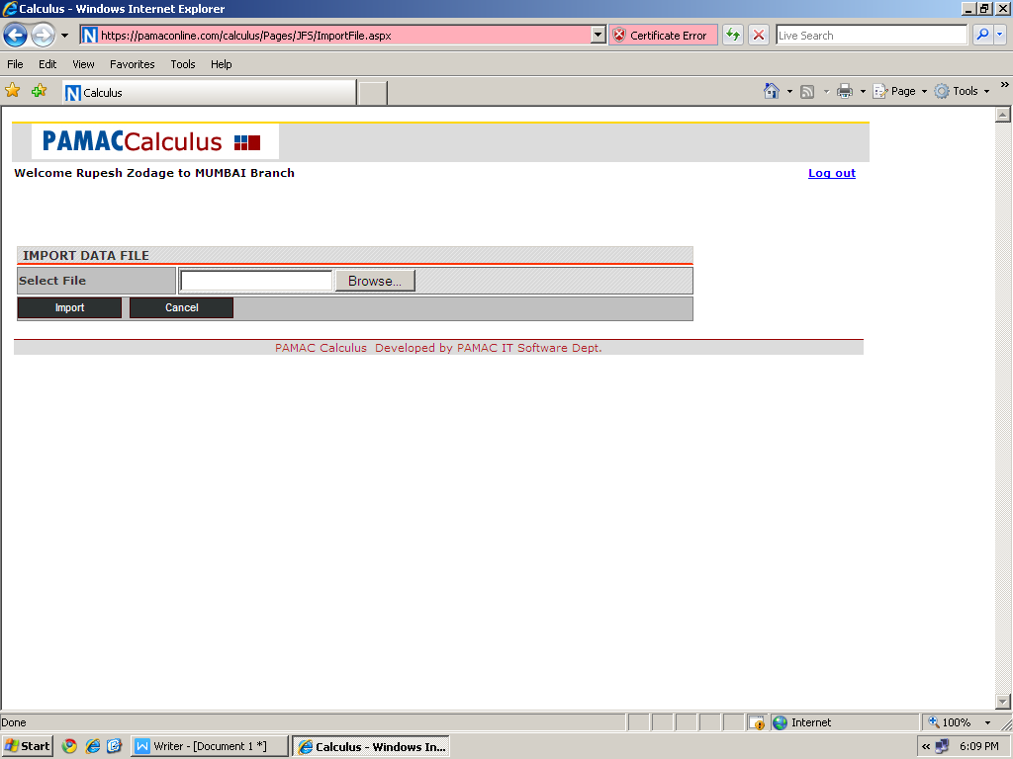

Step 2:Import Updated Status.

Second Import option for Update On Hold Data Entry Reason and Application Status

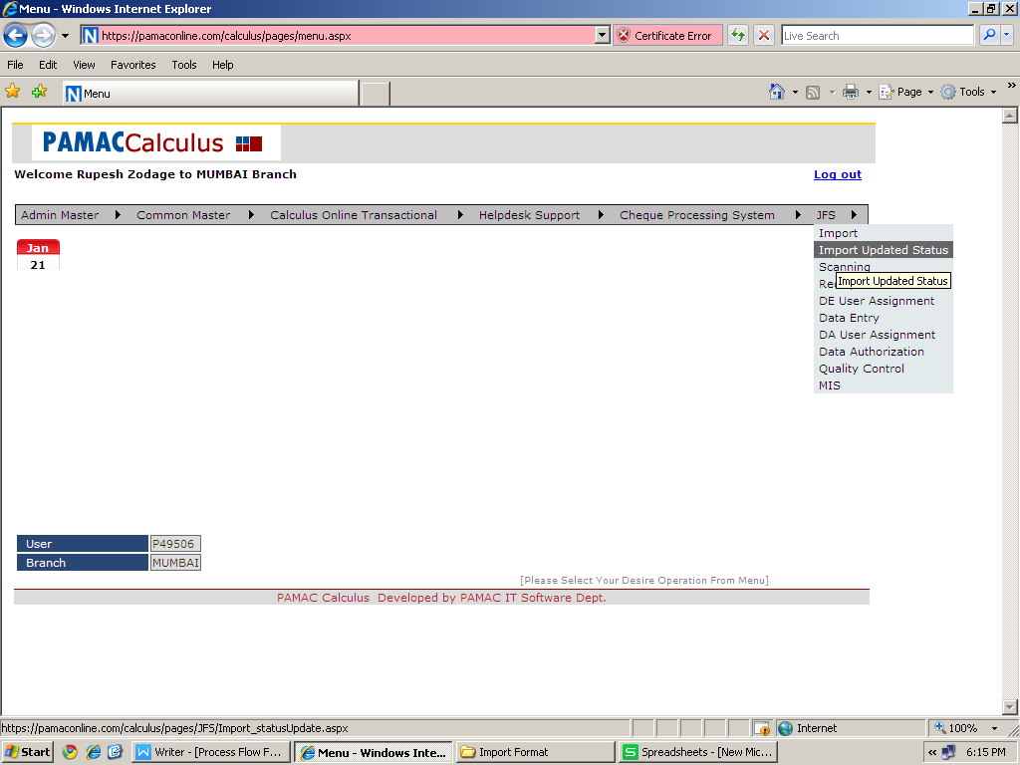

Step 3: Sanning stage
All import cases are display in this stage.It display cases Branch-wise.

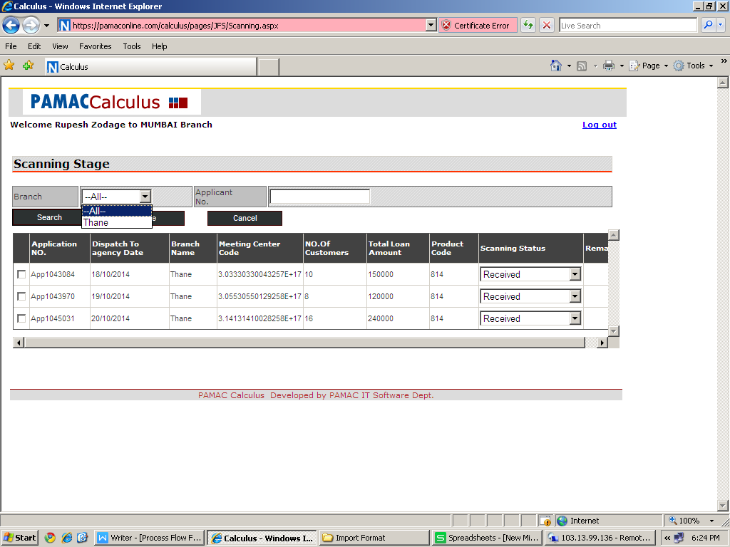

Step 4: Receipt To DDE

- Cases are display in this try After completed Scanning stage.
- If case Scanning Status=’Received With Query’,than it will not display in Receipt to DDE try.

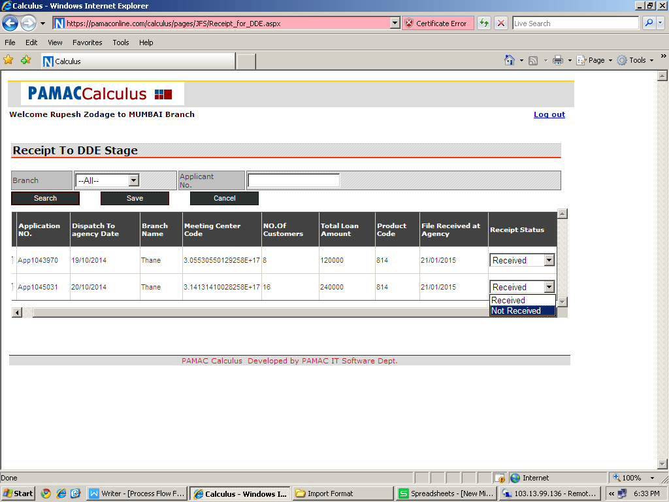

Step 5: DE User Assignment Stage

- It use for manual DE User Assignment.
- It display only those case which have Receipt Status=’Received’.
- It Display DE user Which is login only.
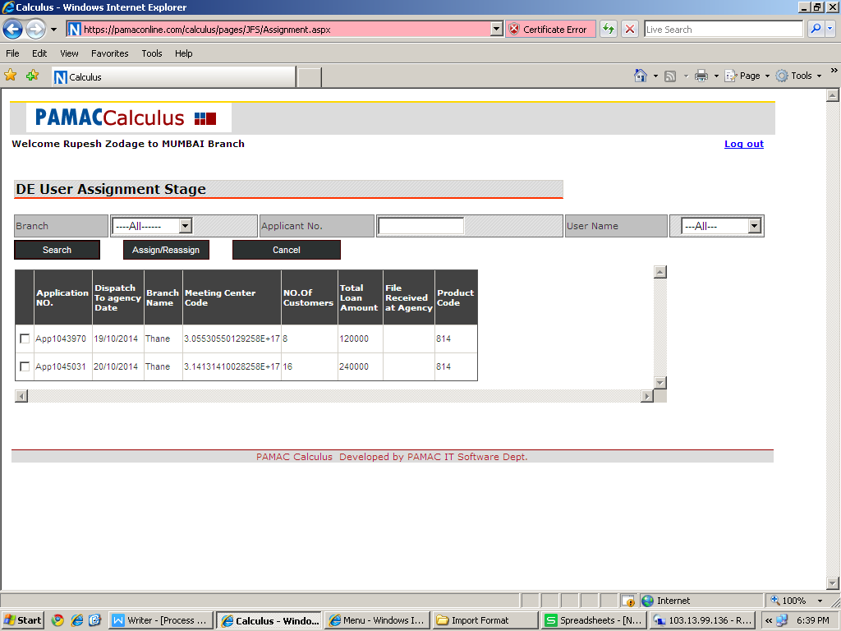

Step 6: Data Entry Stage

1. DE User assign and Receipt status=’Received’ cases are display In this tray.
2. It’s have Auto-assign system,when user login one case automatically assign to that particular user.
3. Once it submit case with Data Entry Status,it get another case and this case send to next stage.

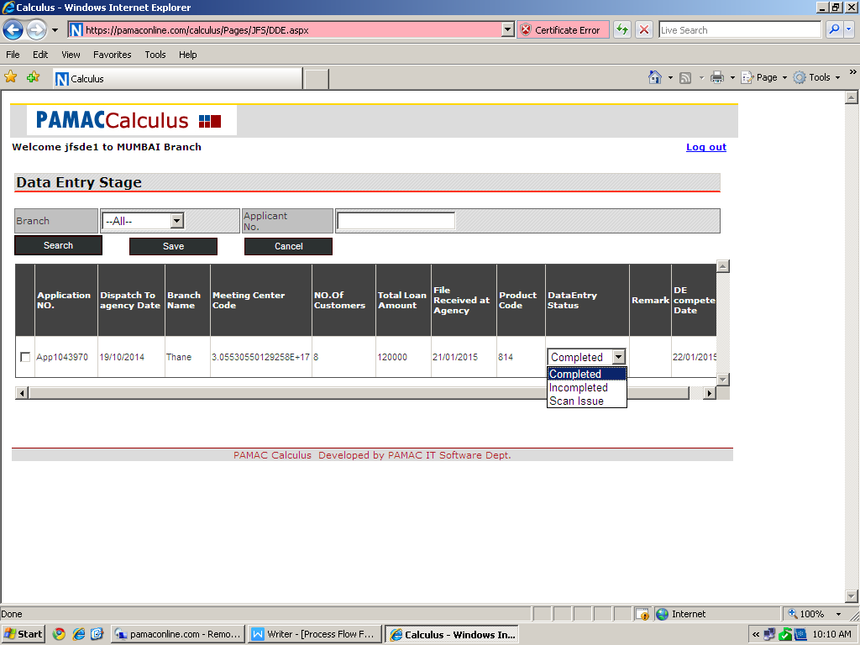

Step 7:DA User Assignment Stage

It use for manual DA User Assignment.
It display only those case which have Data Entry Status=’Completed’.
It Display DE user Which is login only.

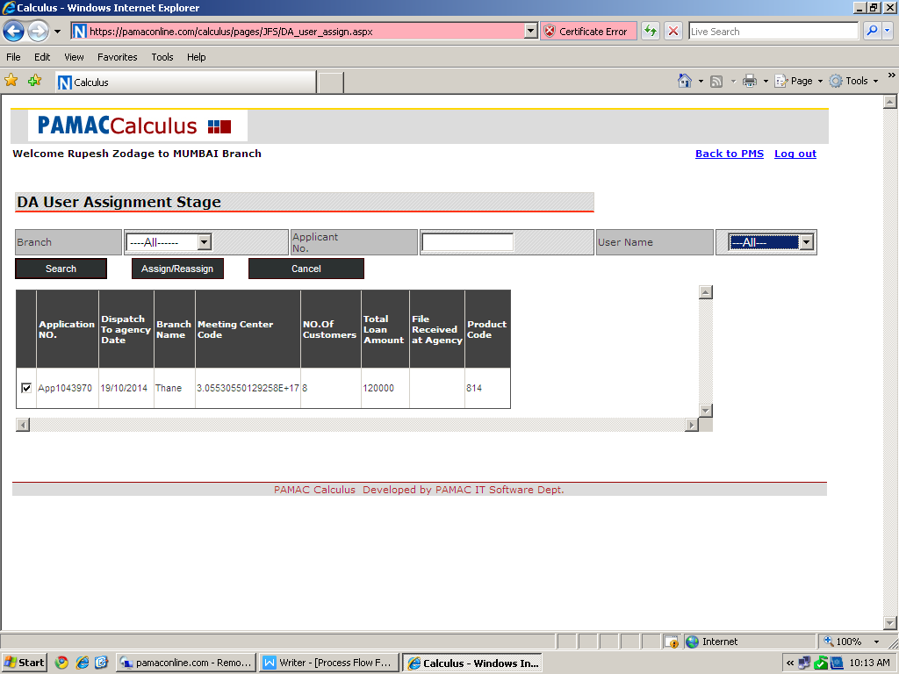

Step:8 Data Entry Authorization stage:

- DA User assign and Data Entry status=’Completed’ cases are display In this tray.
- It’s have Auto-assign system,when user login one case automatically assign to that particular user.
- Once it submit case with DA Status=’Completed’,it get another case and this case send to next stage.
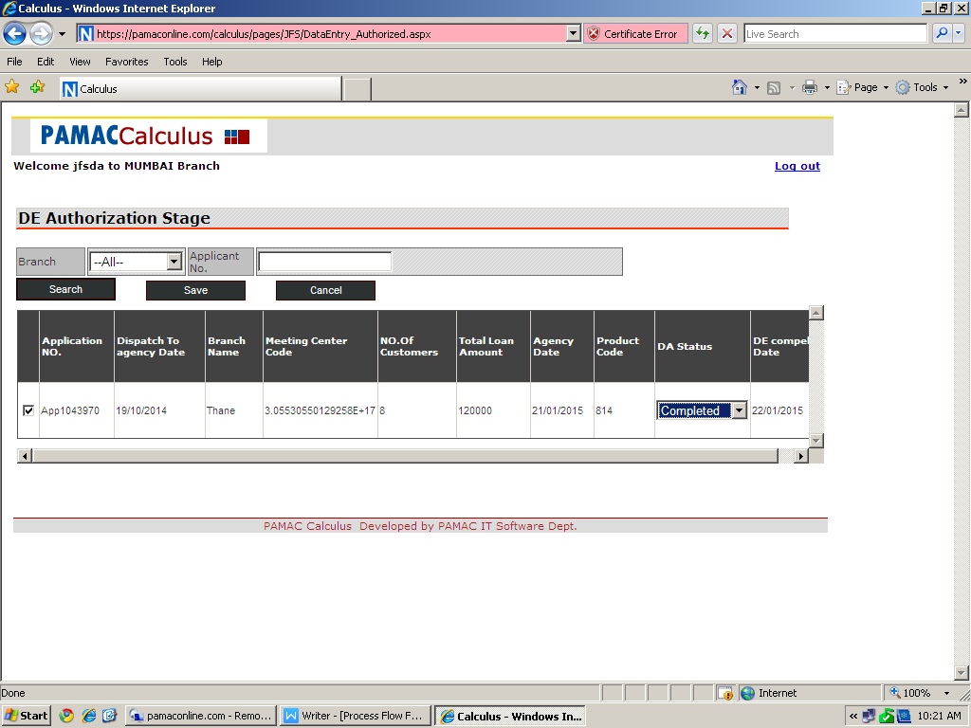

Step 9: Quality Check:

1.It final stage of Process.
2.It contain cases which have DA status=’Complelted’.

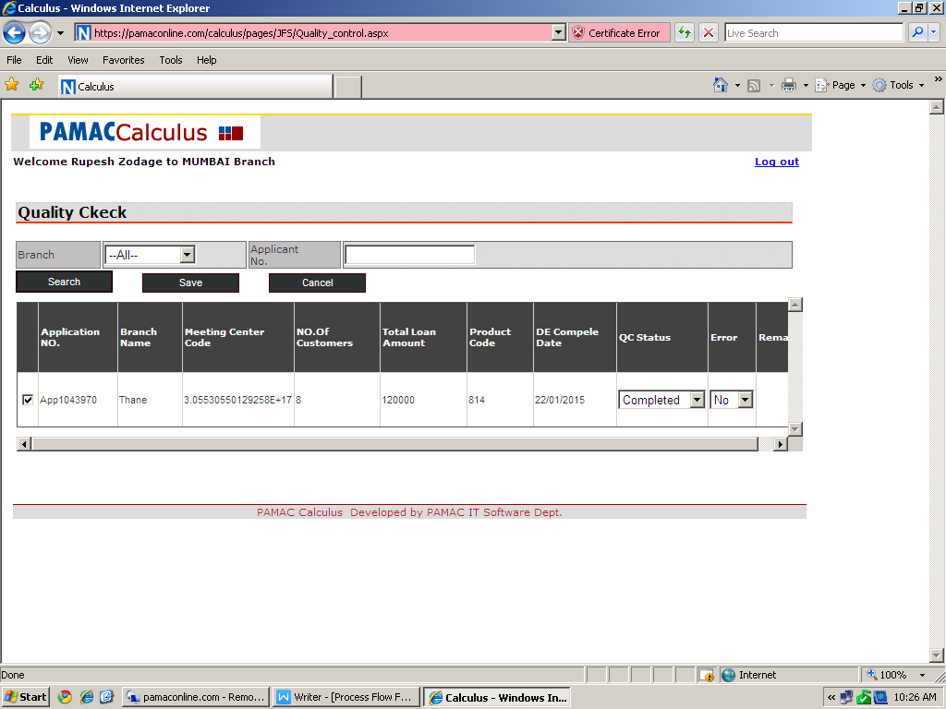

Step 10: MIS

It give MIS report in Xls format
It take scanning date Range.

